NIRMALA MEMORIAL FOUNDATION COLLEGE OF COMMERCE & SCIENCE
20th July 2021
NOTICE
M.Com Part I (Semester I)
(Advanced Accountancy
And
Business Management)

Regular lectures for M.Com Part I (Semester I) will begin on Thursday, 20th July 2022 at 7.30 am.
Time Table for lectures will be shared on your Class WhatsApp Group.
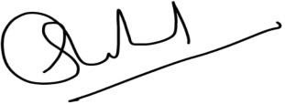
(Principal)
Note: Seating arrangement will be shared

